DSA 0601 Data handling Visulazation
DatePage_ViewsCTR
12023-01-01 15002.3
22023-01-02 16002.7

NAME : S SURENDER

REG NO:1924260070
Set 12: Website Traffic Analysis
Data Visualization using R

Aim
To analyse website traffic using a line chart, a bar chart, a table and a dashboard in R.

Procedure
- Open RStudio and load the packages ggplot2 and gridExtra (install them once with install.packages(c("ggplot2", "gridExtra"))).
- Create the traffic data as a data frame.
- Question 1: draw the line chart of daily page views with geom_line().
- Question 2: sort by CTR, take the top N days and draw the bar chart with geom_col().
- Question 3: make the table with tableGrob().
- Question 4: join the charts and the table into a dashboard with arrangeGrob().
- Run the code and note the output and the figures.

R Code
library(ggplot2); library(gridExtra)

# Dataset
traffic <- data.frame(Date = as.Date(c("2023-01-01","2023-01-02","2023-01-03")), Page_Views = c(1500, 1600, 1400), CTR = c(2.3, 2.7, 2.0))
print(traffic)

# 1. Line chart - daily page views
p1 <- ggplot(traffic, aes(Date, Page_Views)) + geom_line() + geom_point(size = 3) + labs(title = "Daily Page Views", x = "Date", y = "Page Views")

# 2. Bar chart - top N days by CTR N <- 3
top <- head(traffic[order(-traffic$CTR), ], N) print(top)
p2 <- ggplot(top, aes(factor(Date), CTR)) + geom_col(fill = "orange") + geom_text(aes(label = paste0(CTR, "%")), vjust = -0.5) +
labs(title = paste("Top", N, "Days by CTR"), x = "Date", y = "Click-through Rate (%)")

# 3. Table
tb <- tableGrob(traffic, rows = NULL)

# 4. Dashboard
dash <- arrangeGrob(p1, p2, tb, layout_matrix = rbind(c(1,2), c(3,3)), top = "Website Traffic Dashboard")

ggsave("set12_q1.png", p1, width = 6, height = 4, bg = "white") ggsave("set12_q2.png", p2, width = 6, height = 4, bg = "white")
ggsave("set12_q3.png", arrangeGrob(tb, top = "Website Traffic Table"), width = 5, height = 2, bg = "white") ggsave("set12_q4.png", dash, width = 12, height = 8, bg = "white")

Output

3 2023-01-03 1400 2.0
Date Page_Views CTR
2 2023-01-02 | 1600 2.7
1 2023-01-01 | 1500 2.3
3 2023-01-03 | 1400 2.0

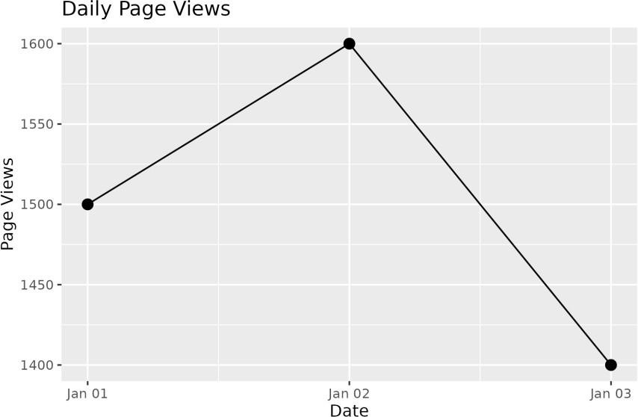

Figure 12.1: Q1 - Line chart of page views
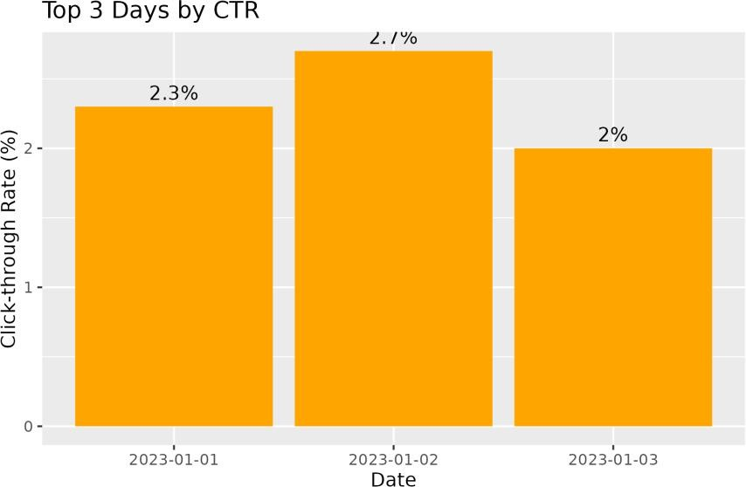

Figure 12.2: Q2 - Top N days by CTR
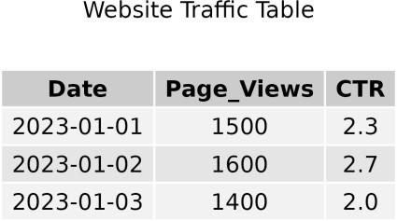

Figure 12.3: Q3 - Website traffic table

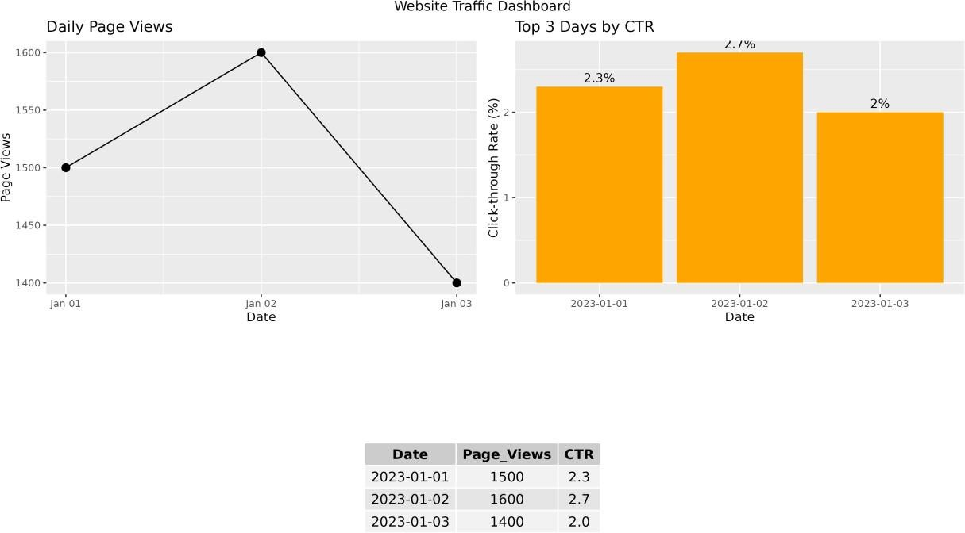

Figure 12.4: Q4 - Dashboard

Result
- Page views were highest on 2 Jan (1600) and lowest on 3 Jan (1400).
- The highest click-through rate was 2.7% on 2 Jan.
- All four parts were completed successfully in R.

